Name- OLUWAGBOTEMI BANJO

Student ID - 00641130

# Table of Contents

Contents

Table of Contents 2

Task 1 3

1. Abstract 3

2. Introduction 4

3. Relational Schema 4

4. Identifying The Tables 4

5. Creating Relationships Between Tables 6

INDIA DIAGRAM 7

Vietnam DIAGRAM 7

6. Creating the tables 8

7. Design Rationale 10

8. Design Considerations 10

9. STORED PROCEDURES 15

10. Database security 17

11. Database Backup and Restore Strategy 18

12. Data Privacy,Ethical and Legal Issues 18

13. Data Science /Business Intelligence CONCLUSION 18

CONCLUSION 18

Task 2 19

1. Abstract 19

2. Introduction 19

3. Design Rationale 19

SCRIPTS FOR THE VIETNAM WAVE TABLE 19

REPORTS 22

4. Design Considerations 23

5. T-SQL Statements 24

6. Report Design 25

7. Database Backup and Restore Strategy 27

8. Data Science /Business Intelligence – 27

9. Data Privacy,Ethical and Legal Issues – 27

10. Conclusion 27

Task 3 28

1. Abstract 28

2. Introduction 28

3.Design Rationale 28

4. T-SQL Statements 29

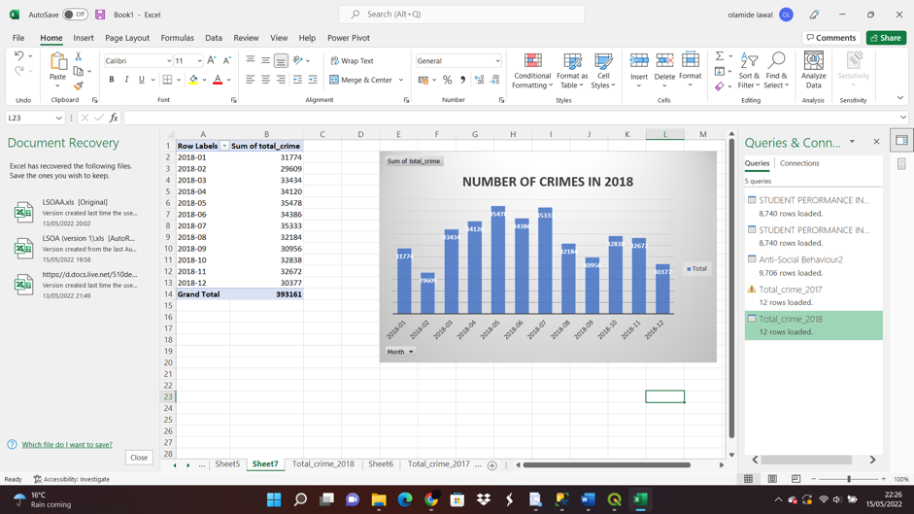 32

6.Database security 33

7.Database Backup and Restore Strategy 33

8.Data Science /Business Intelligence 33

9.Data Privacy,Ethical and Legal Issues 33

10.Conclusion 34

# Task 1

# Abstract

This project entails developing a reporting tool called Child Well-Being Monitor, which was designed to analyse data on child poverty in Vietnam, Ethiopia, and Peru. The goal is to make it easier for users to extract important information and show data in charts, tables, and other visualisations to obtain important information. The goal of this reporting tool is to turn data into actionable knowledge by creating a series of reports to foster in the understanding of child poverty in low-income nations. The dataset for this study came from the Young Lives project, India, Ethiopia, Peru, and Vietnam are the countries selected for this research based on a wide range range of issues and experiences affecting developing countries , ranging from issues like debts to drought, flooding and post-conflict reconstruction.

To achieve the aim of this task , a database was created for this purpose named ‘Child_Monitor’. After which the dataset from the Young Lives data was imported into database. A schema was created for the four different countries and five different tables were created .The tables created have diiferent columns that were used in analyzing the reports, These tables were grouped based on data relating to the child and the child characteristics , the environment,diseases,health and wellbeing.Stored procedures were also used to create statements which are used to change the data type and to create primary key for each of the tables .At the end of the project 5 different views were created to develop the reports to measure the child poverty in Ethiopia, India, Peru and Vietnam.

# Introduction

The Young Lives survey is a long-term project that is to investigate the causes of the root causes of childhood poverty in the four developing countries that have been selected for this project . The main aim of this project is to give a better understanding on the causes and effects of childhood poverty and find insight on how an innovative long-term project investigating the changing nature of childhood poverty in four developing countries. The purpose of the project is to improve the understanding of the causes and effects of childhood poverty and examine how children's well-being is influenced by policies in order to to better target child welfare initiatives and to influence future policy development.The study is being conducted in Ethiopia, India, Peru and Vietnam are the countries selected based on the facts that they are having challenges that affects developing countries like diseases , war, flood ,economical challenges, drought.

# Relational Schema

A relational schema is a group of relational tables that are connected to one another.with the use of statements schemas .With the creation of the schema ,it gives the permission to create tables and to write statements that allows other users to have access . A primary key  is a column or columns within a table whose unique values identify a row in the table. A relational schema is designed to maintain the uniqueness of primary keys by allowing only one row with a given primary key value in a table, in this project the primary key in the relational schema is (child and round). The primary key is also the forign key and it helped in creating the link beween the tables.Primary keys were created for all the tables in the process of this project.

# Identifying The Tables

The tables used to analyse the young lives data were specifically selected based on different issues that are mostly health related . The selected countries have the same tables, the tables are children identification, children characteristics ,children anthropromeric measures , children birth and immunisation , children illness ,injuries and disability. The tables are further explained below-

* Children Identification : This table explains the different columns that are attributed to the identity of each child , beginning with Children identification which is a unique identification (childid) that was assigned to each child, the ‘ID’ was retained mainly used for tracking each child. The first two characters of the childid are the country initials (ET for Ethiopia, IN for India, PE for Peru, and VN for Vietnam). while the next two characters is the cluster ID (clustid),the Cluster id’s are assigned to every sentinel site that Young Lives visited. Round it represents round of each survey, the Child-id and round columns are well represented in all the five tables . While the ‘deceased’ column was added to specify if the child questionnaire was administered in all five survey rounds and if the child has died.In the children identification there are ther columns like round(round of survey),commid(which means community id),typesite(area of residence-either urban or rural),childloc(child currently lives in the house),yc(younger cohort).
* Children general Characteristics :this table has columns that have information on the children’s characteristics like childid and round which have been explained in the children identification table . The children general characteristics tables has other columns like

chsex- child sex

chethnic-child’s ethnic group

agemon-child’s age in months

marrcohab- child has ever been married or cohabited

marrcohab- age of child at first marriage or cohabitation

birth – child has a son or daughter

* Children Athroprometric measures - this table has columns that have information on each child’s body composition, it has columns like chweight(childweight-kg),chheight(child height-cm),bmi(calculated bmi ), underweight(low weight for age ), stunting(short height for age ), thinness(low Bmi for age)
* Children birth and immunization -- this table has columns that have information on birth, antenantal and immunizations against specific illness .It has columns like bwght(child’s birth weight-grams), numate(number of antenatal for each mother dueing pregnancy),tetanus(if the mother received at least two tetanus injections during pregnancy),delivery(if the mother was attended to by skilled health officials during delivery),bcg,measles,polio,dpt,hib
* Children illness , injuries and disabilities - this table has columns that have information on the children’s history of sickness , injury and disabilities and disabilities – chmightdie, chillness, chinjury, chhprob, chdisability.

# Creating Relationships Between Tables

A composite key was created in each table using composite keys using childid and round(childidround), for the tables to relate to each other. This becomes the foreign keys to link the tables, the tables are joined/connected to eachother. The following diagrams were created. Below is a diagram of how a primary was created. The screenshot below shows how the ptimary key for peru was done.

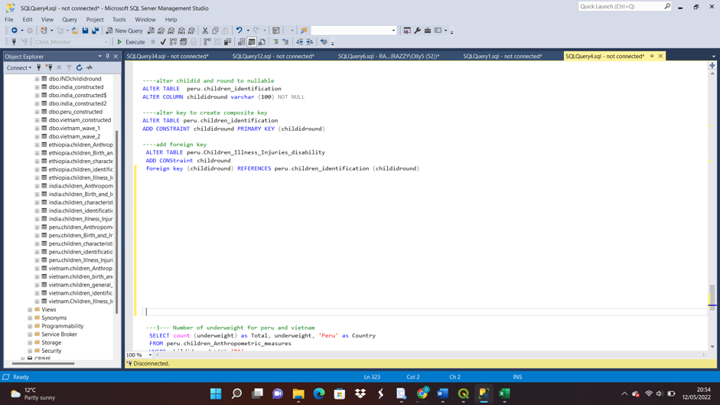

The following screenshots shows the connection between all the tables in each screenshot .

# INDIA DIAGRAM

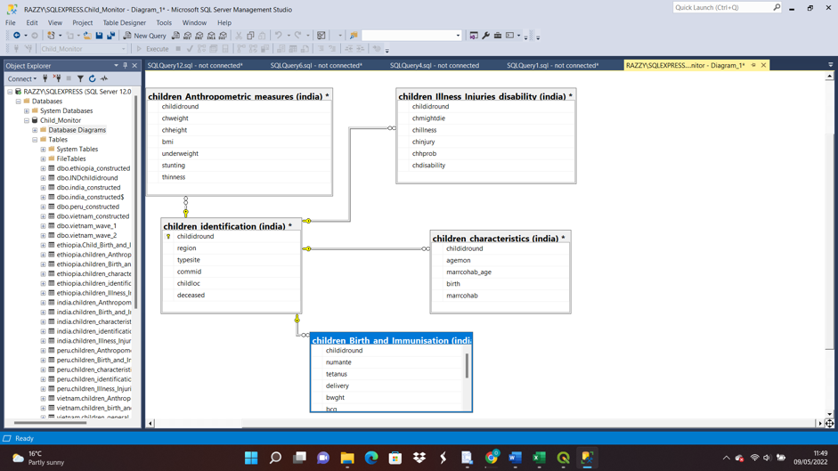

# Vietnam DIAGRAM

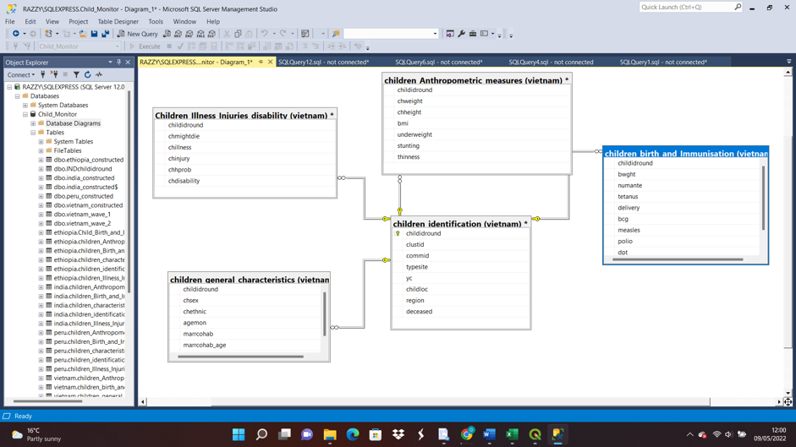

PERU DIAGRAM

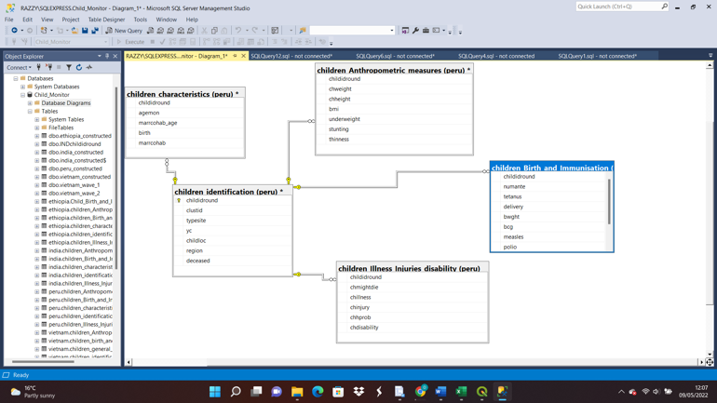

ETHIOPIA

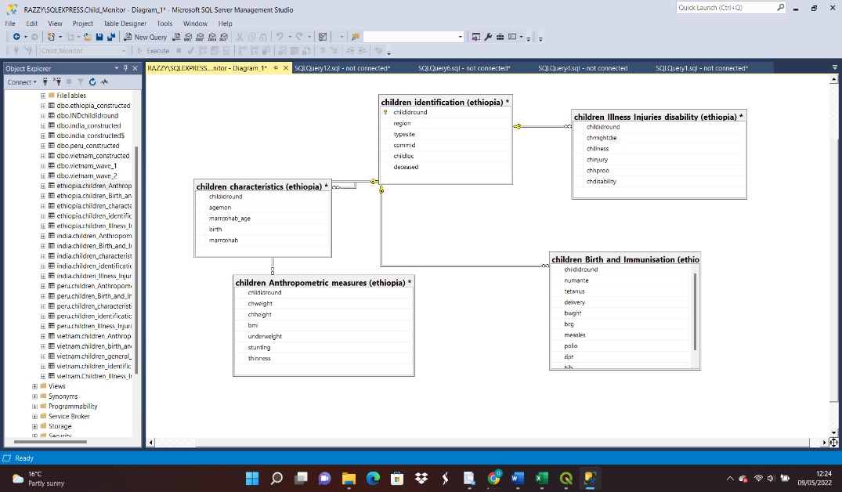

# Creating the tables

In the process of analysing the child poverty data , five tables were imported into sql_server management system (SSMS). These tables were created for the four countries that are being analysed – Vietnam,Ethiopia,India,Peru, the tables created are Children Identification , children general characteristics , children anthropometrics measures, children birth and immunization ,children illness, injuries and disability . The tables were grouped based on specific data relating to health crisis, emergence from conflict, and vulnerability to environmental conditions that tackle children welfare.In the process of creating the tables different columns were inserted including the primary key .Below are screenshots of the tables created for the four countries -Vietnam, India ,Ethiopia, Peru.

SCRIPT FOR VIETNAM TABLE

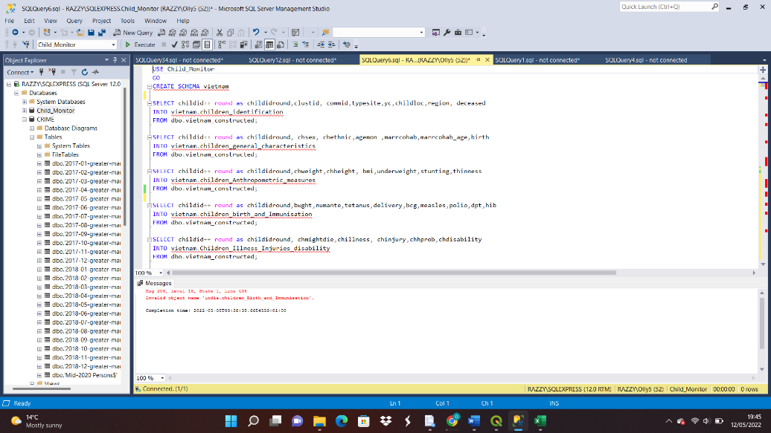

SCRIPT FOR INDIA TABLE

-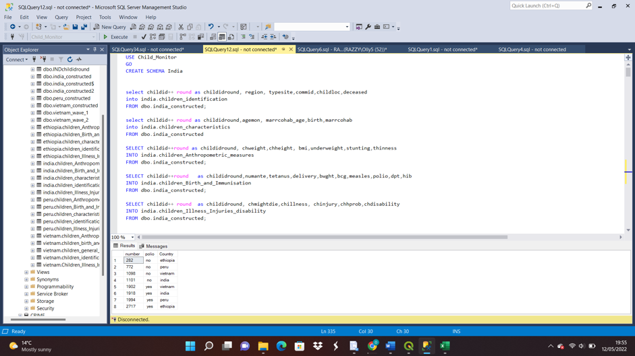

SCRIPT FOR ETHIOPIA TABLE

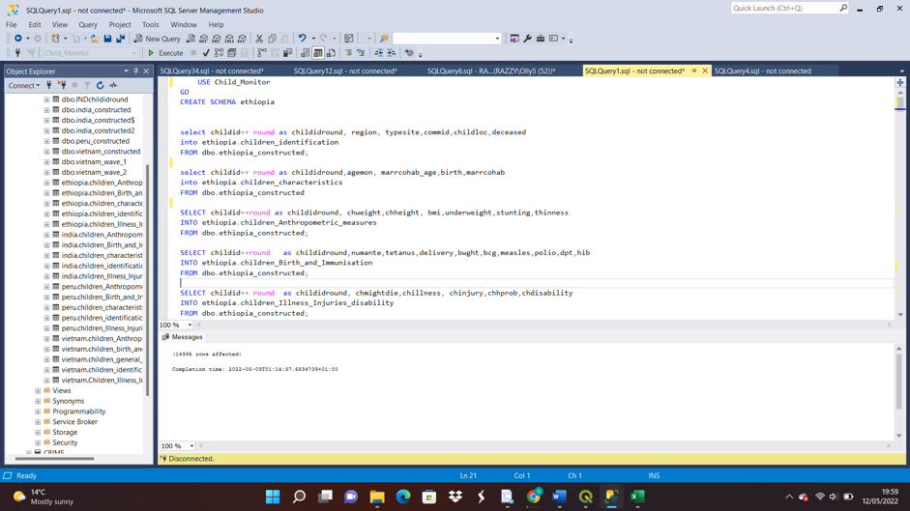

SCRIPT FOR PERU TABLE

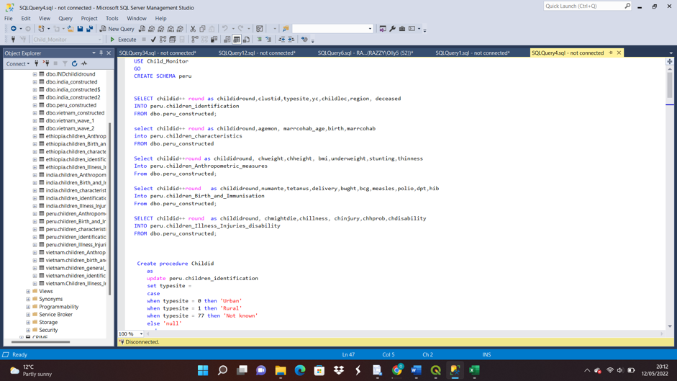

# Design Rationale

In creating the views and report, the rationale behind it was analyzing issues that are health related to investigate the root causes of childhood poverty and how this topics affcets childhood poverty in these countries and how the insights gotten from the results can be used to make informed decisions .

# Design Considerations

DATABASE NORMALISATION:

Database normalization is the process of arranging columns and tables of a database in a database to make sure that database integrity are effectively enforced.

CONSTRAINTS:

Constraints are implemented to limit the data type that are inserted in a table.Constraints are used to ensure the reliability of the type of data that go into a table.In the course of this project a good number of constraints were applied .some of the ones that were used in this project are as follows ;

* Not Null- it’s used to ensure that a column does not have a NULL value
* Primary key – it’s a unique value that is present in all tables , in the case of this project ‘childid+ round’ = ‘childidround” was the primary key .
* Foreign key – In this task the primary key was also the foreign key .

DATAVALIDATION :

The data used in this task were validated in Microsoft excel before importing into ssms to ensure that the right data was correct and useful for analysis .

TRANSACTION AND CONCURRENCY:

This project had no reasons to use this controls because it’s not a transactional database The assignment did not use any of this controls because the database had no transactions , it was only used to analyse data .

SECURITY :

Database security can be seen as measures that are put in place to preserve the availability and confidentiality of a database. Database security protects the data, database management system , the virtual and physical server and the networking infrastructure used to access the database.

COMMENTS :

Comments were used to give better description to the statements or to stop the execution of sql statements.

TABLES :

In the process of analysing the child poverty data , five tables were imported into sql_server management system (SSMS). These tables were created for the four countries that are being analysed – Vietnam,Ethiopia,India,Peru, the tables created are Children Identification , children general characteristics , children anthropometrics measures , children birth and immunization ,children illness, injuries and disability . The tables were grouped based on specific data relating to health crisis, emergence from conflict, and vulnerability to environmental conditions that tackle children welfare.In the process of creating the tables different columns were inserted including the primary key .Below are screenshots of the tables created for the four countries -Vietnam, India ,Ethiopia, Peru

VIEWS

Views were created to store analysed data which were used to create reports. The reports were done on different issues that are health related. The views created contributed in analysing the reports.

SCRIPTS FOR VIEWS

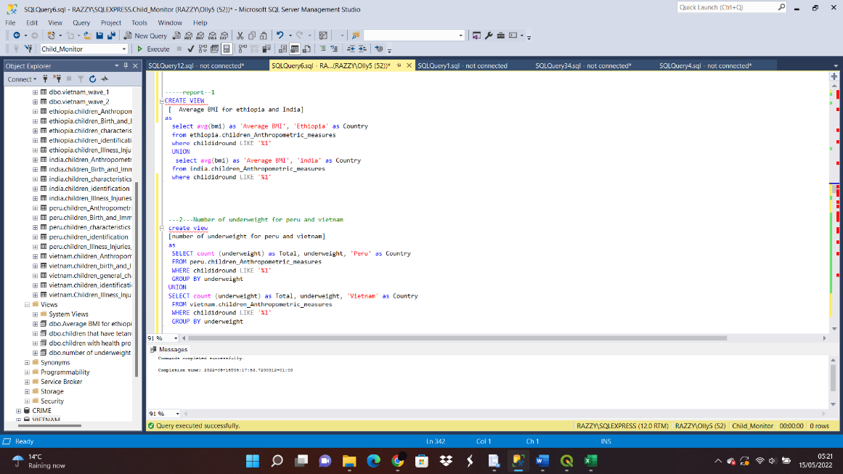

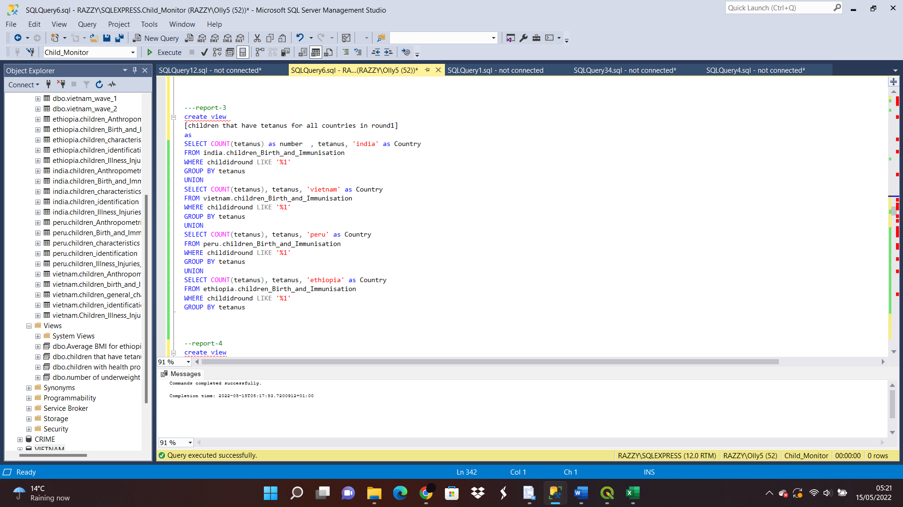

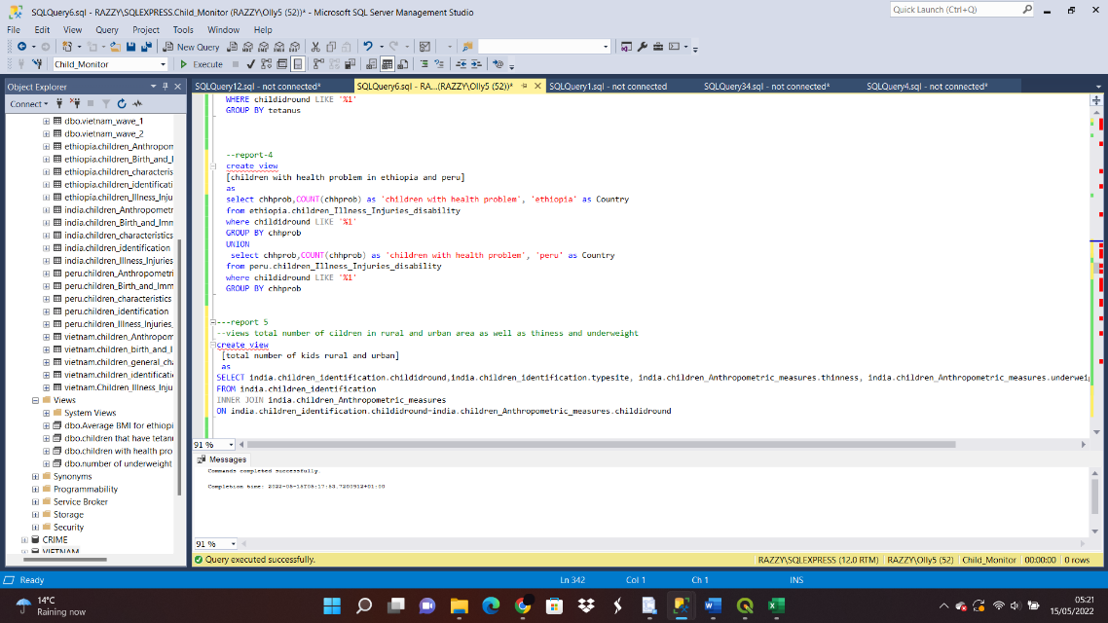

SCRIPT FOR CREATING STORED PROCEDURES FOR PERU

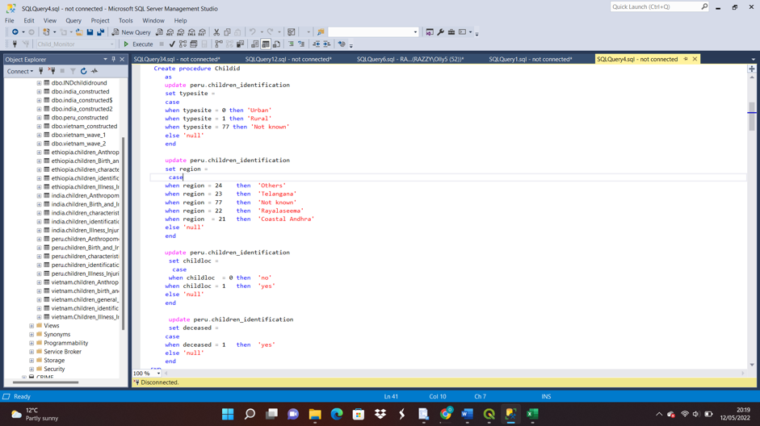

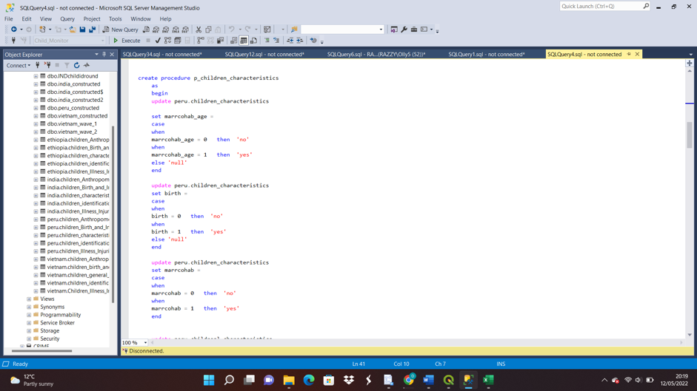

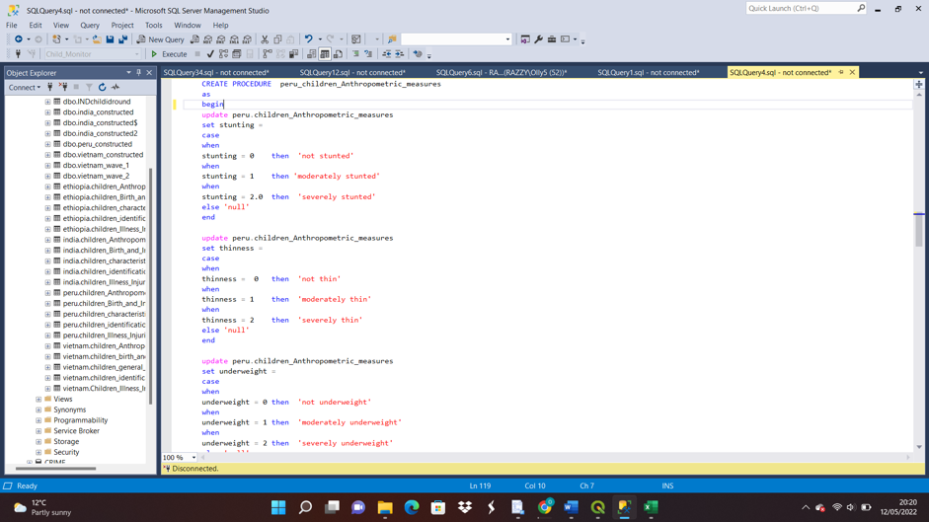

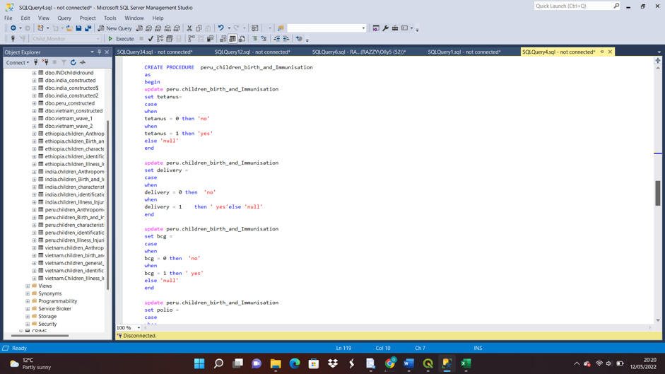

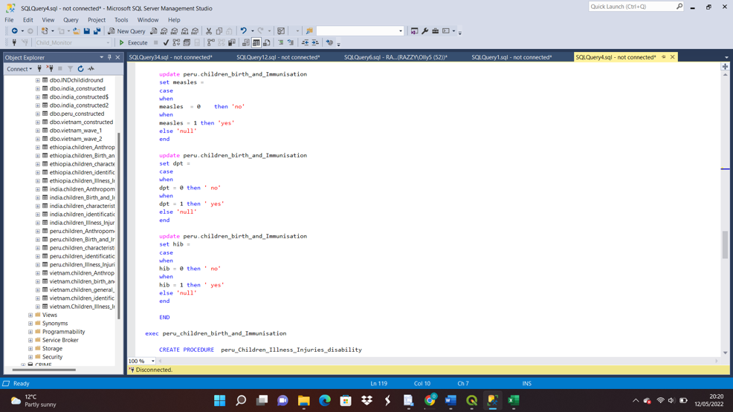

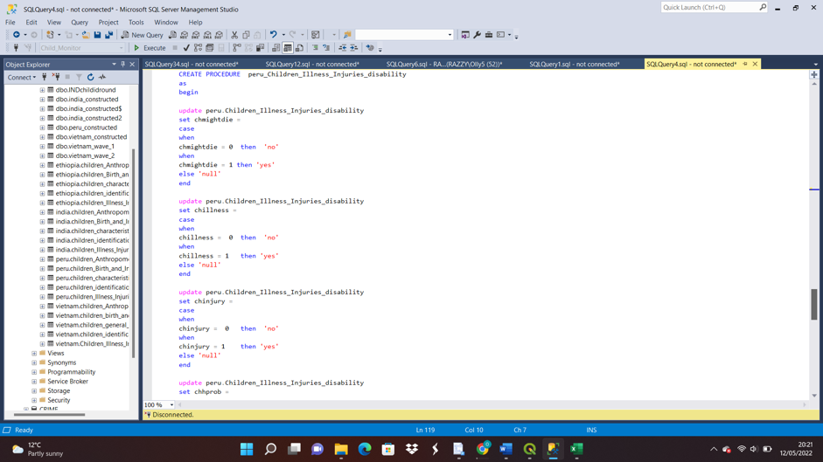

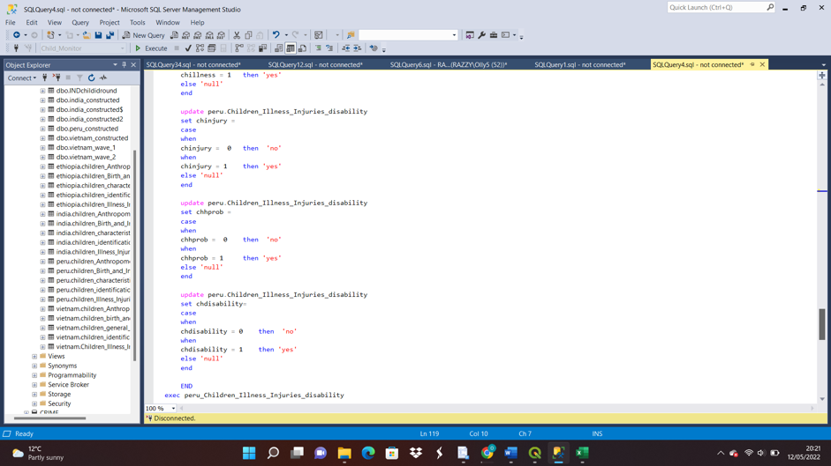

PRIMARY KEY



# STORED PROCEDURES

stored procedure were used in altering the data for all the tables

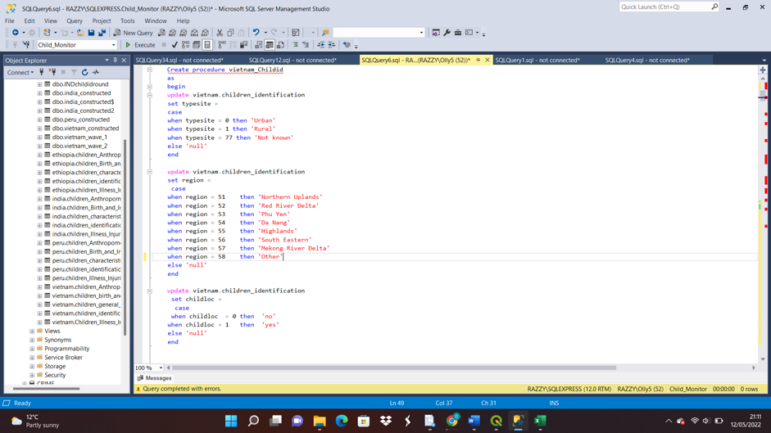

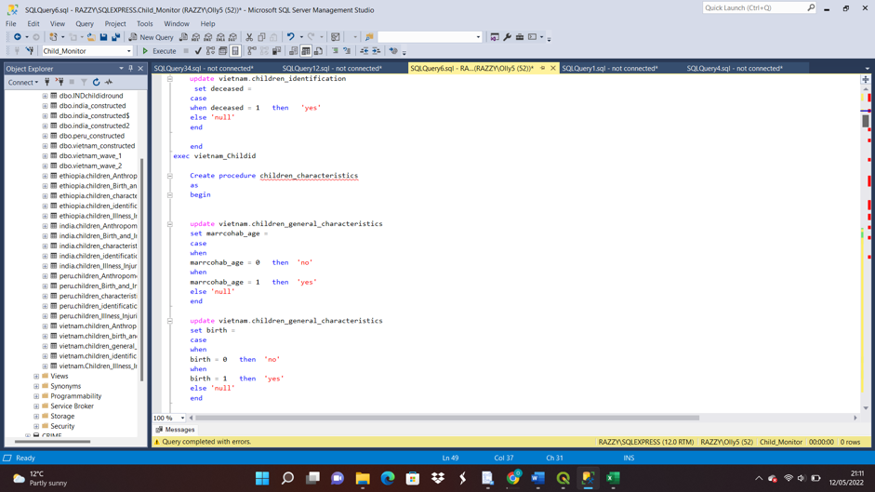

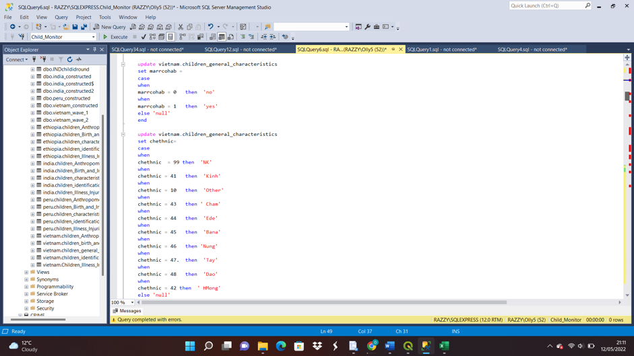

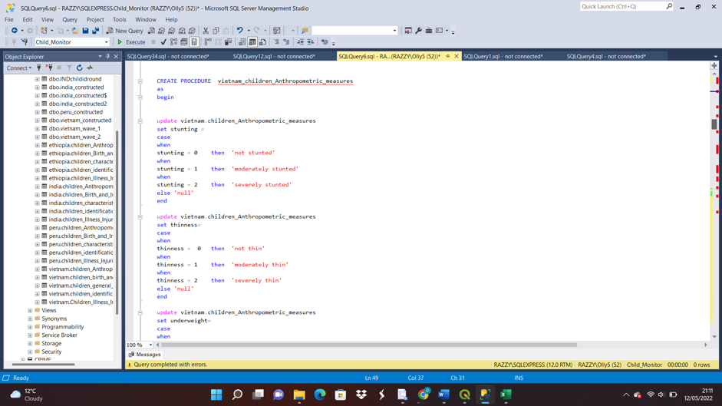

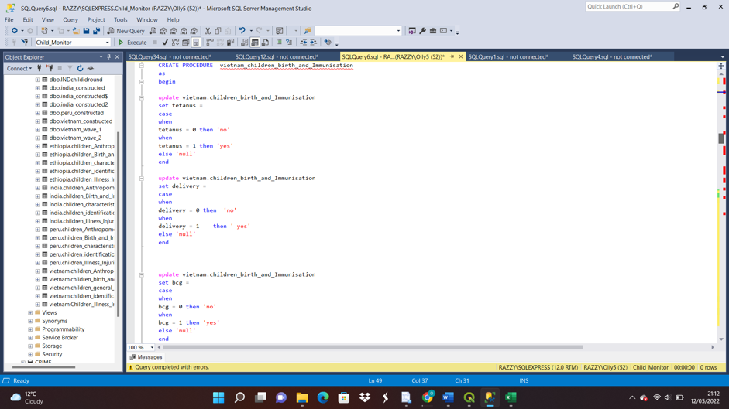

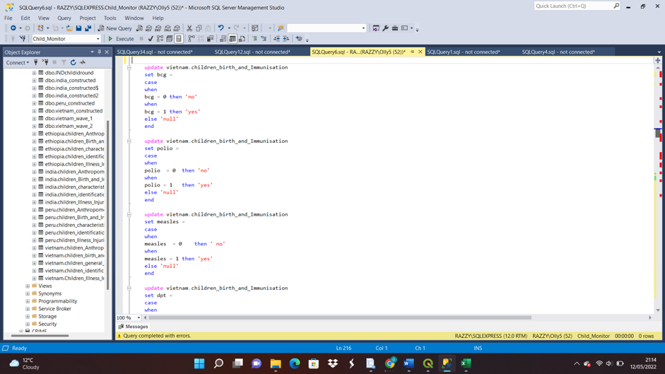

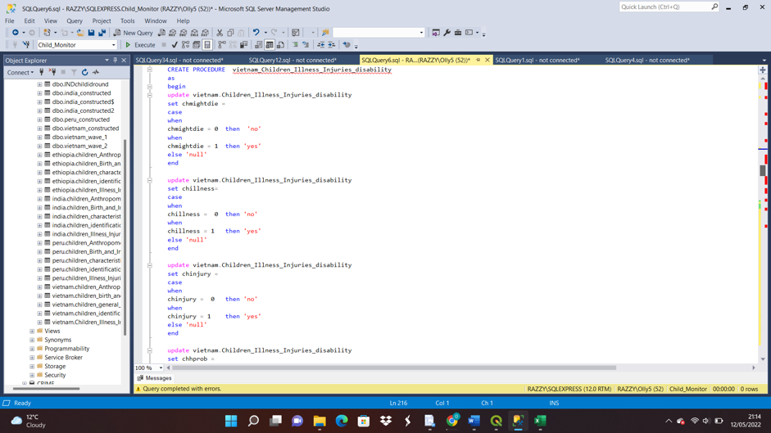

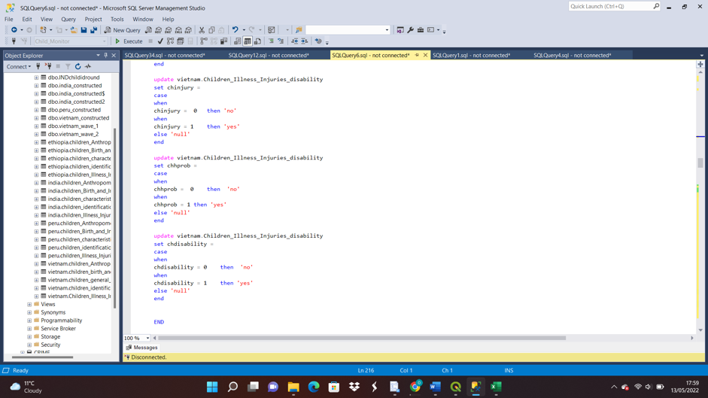

# Database security

Database security was introduced to avoid illegal access or modificationof the database. Database security is an essential part of any organization's overall information systems security plan because the database is such a vital business resource.

# Database Backup and Restore Strategy

SQL Server backup and restore is a key safeguard for critical data stored in SQL Server databases. To reduce the danger of catastrophic data loss, you should regularly back up your databases to preserve data revisions. A well-thought of backup and restore strategy protects databases from data loss due to a number of problems, a screenshot of the backup is below . To prepare to respond effectively to a disaster, test your plan by restoring a set of backups and then recovering your database.

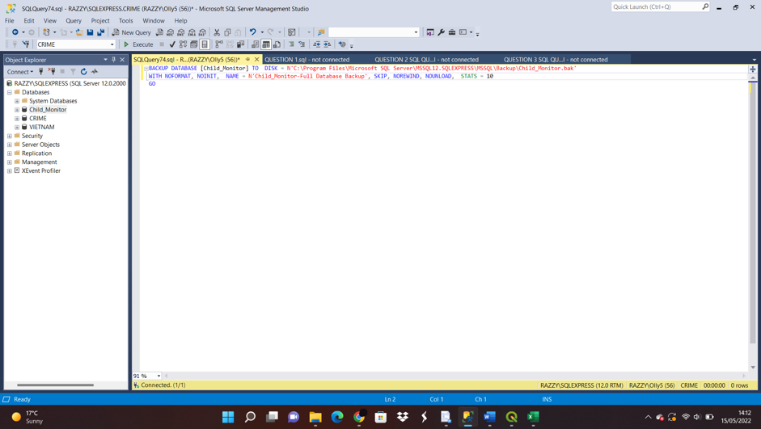

# Data Privacy,Ethical and Legal Issues

On the internet, unlawful data copying (data piracy), illegal access and interception, device misuse, computer-related forgeries, fraud and copyright and related rights infringements are all considered ethical issues.

# Data Science /Business Intelligence CONCLUSION

Both business intelligence and data science are important in creating actionable insights in any organisation.The type of data they deal with to project deliverables and techniques, BI and data science differ in a number of ways.

# Task 2

# Abstract

This project analyses the education sector in Vietnam ,making use of the young lives school survey,Vietnam 2016-2017 dataset. The aim of this project was to get a better understanding of the relationships between the class, the school,teachers,children home background and learning outcomes . The dataset used for this project was converted into an excel file and imported into SSMS to analyse. The Vietnam young lives school survey data had two different datasets – Vietnam_wave1 and Vietnam_wave2 , the tables created for the analysis were created using information from Vietnam_wave1. After these tables were created , views were for storing grouped data and the analysed data. With the use of Microsoft excel the analysed data was used as the presentation tool.

# Introduction

The Young Lives: School Survey, Vietnam, 2016-2017 dataset is about a survey that was carried out in 2010 for the young lives project, its aim was to discover useful information on the relationships between the pupils , their environment and background , teachers , school and school facilities and their outcome.The survey entails three different components that were used in carrying out the survey that covered different issues , the components are community questionnaire , household questionnaire,child questionnaire.

# Design Rationale

In analysing this project, Vietnam_wave1 dataset was selected. The dataset was converted to an excel file format and imported into the SQL Server Management Studio for analysis.Different tables were created from the imported dataset based on the students health, identification,general information , students results , school details , students reasons for selecting schools. The tables created were analysed towards discovering discovering the relationships between the students , the school and it’s teachers , student’s background and their outcomes.

# SCRIPTS FOR THE VIETNAM WAVE TABLE

The tables created were analysed towards the analysing the young lives school survey, to start the analysis a schema named vietnam_wave1 was created and twelve different tables were created . The tables are children identification , children health condition, children health condition, children general information ,students results , school details, children’s reason for choosing school , school details , students details etc. The columns in the tables have attibutes that contributes to the formation of each table an example is the table – Vietnam_wave_children_identification had columns like gender ,ethnicity, school id , students id , unique id , these columns listed all represents the identity of the children and how they can be easily identified . The screenshots below shows how the schema was created and hpw each tables was created .

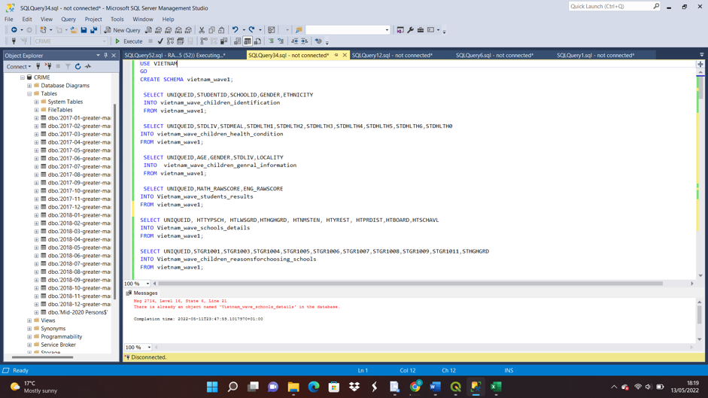

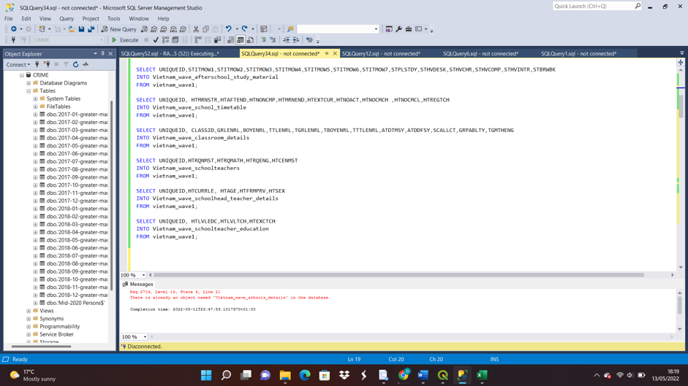

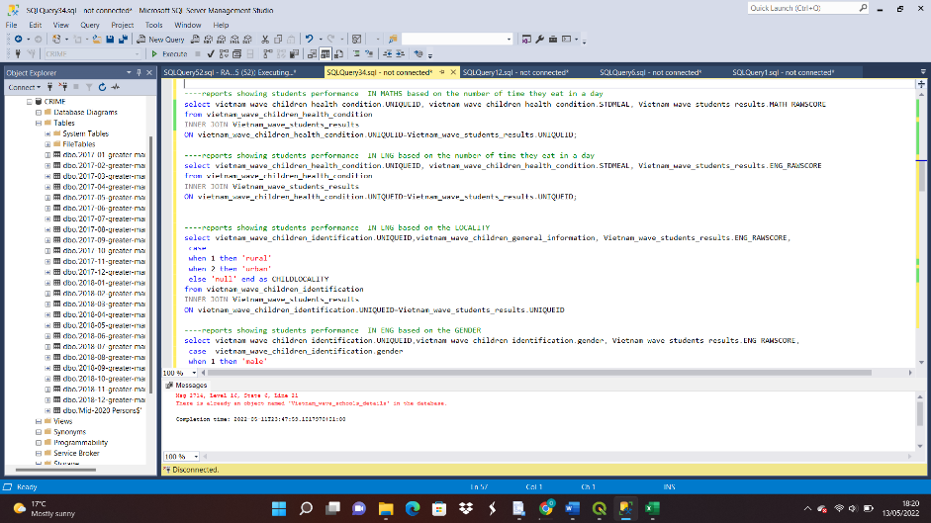

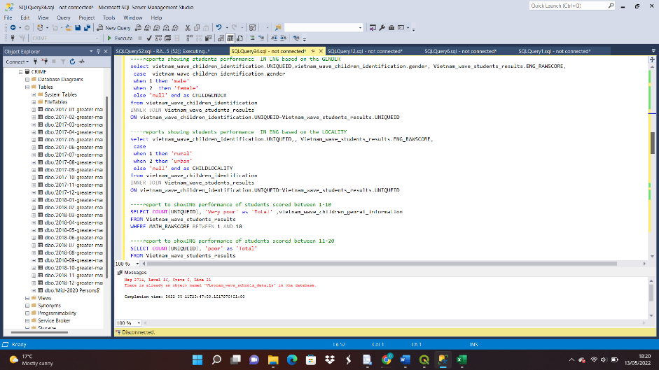

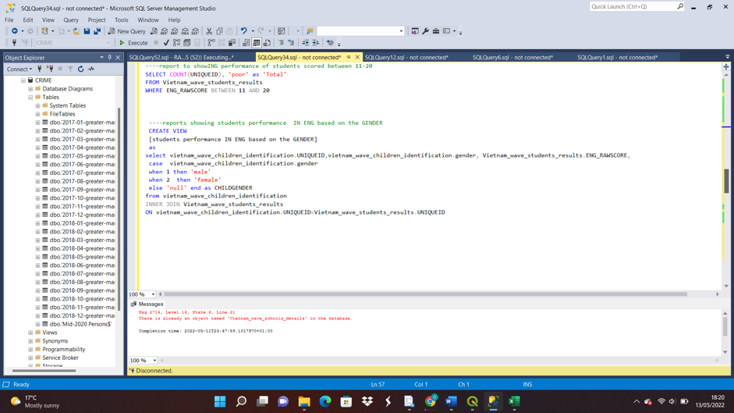

# REPORTS

The reports were implemented on the vietnam school survey were created to measure and understand the inequality in the education sector of Vietnam , the reports in this project measured the inequality in the students school performance based on their Locality,gender , how their health condition affects the students performance and how their feeding habits affects their performance in school.

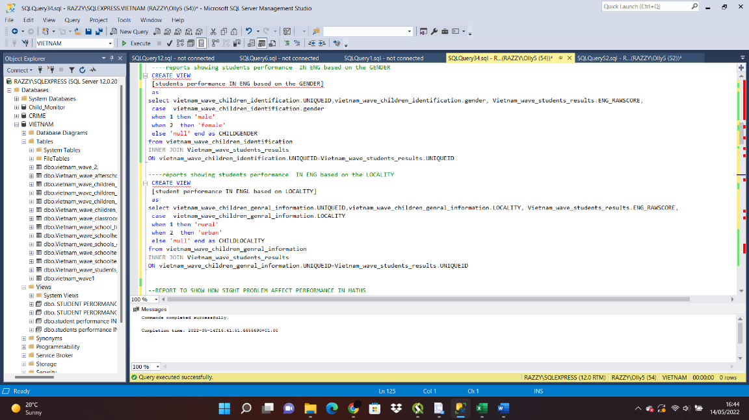

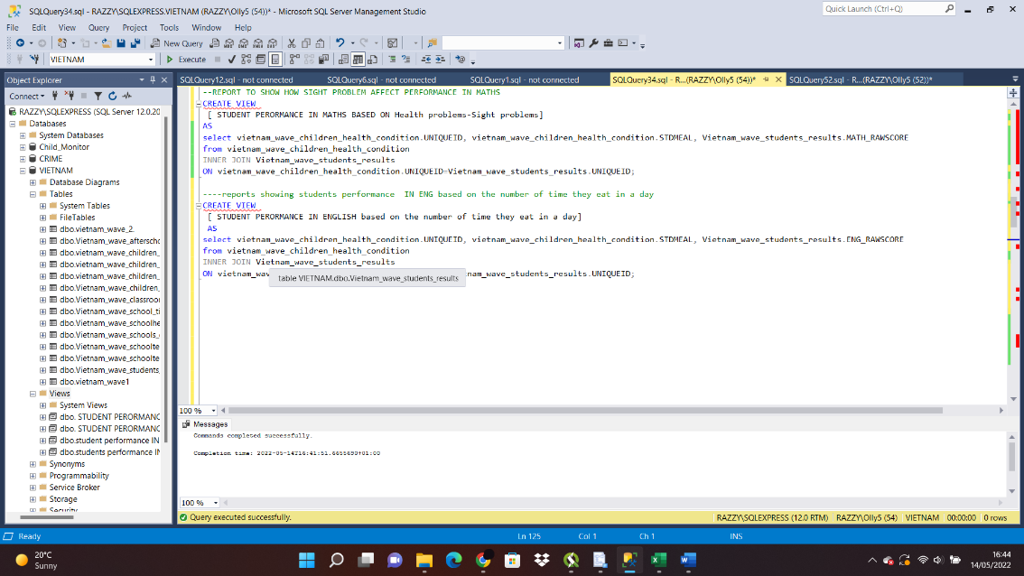

# Design Considerations

DATABASE NORMALISATION:

Database normalization is the process of arranging columns and tables of a database in a database to make sure that database integrity are effectively enforced.

CONSTRAINTS:

Constraints are implemented to limit the data type that are inserted in a table.Constraints are used to ensure the reliability of the type of data that go into a table.In the course of this project a good number of constraints were applied .some of the ones that were used in this project are as follows ;

* Not Null- it’s used to ensure that a column does not have a NULL value

DATAVALIDATION :

The data used in this task were validated in Microsoft excel before importing into ssms to ensure that the right data was correct and useful for analysis .

TRANSACTION AND CONCURRENCY:

This project had no reasons to use this controls because it’s not a transactional database The assignment did not use any of this controls because the database had no transactions , it was only used to analyse data .

Error Handling

SECURITY:

Database security can be seen as measures that are put in place to preserve the availability and confidentiality of a database . Database security protects the data , database management system , the virtual and physical server and the networking infrastructure used to access the database.

COMMENTS :

Comments were used to give better description to the statements or to stop the execution of sql statements.

TABLES :

In the process of analysing thevietnam school survey data , twelve tables were imported into sql_server management system (SSMS). These tables were created with columns in that have attibutes that contributes to the formation of each table .The tables were tables created were towards discovering the relationships between the students , the school and it’s teachers , student’s background and their outcomes.

VIEWS

Views were created to store analysed data ,which were used to create reports/visualisation . The reports were done on different issues that are health related. The views created contributed in analysing the reports .the view were





# T-SQL Statements

VIEWS

T-sql statements were used in creating views to store the analysed data which were used to create reports. The reports were done on different issues that measured the inequality in the students school performance and contributed in visualizing the analysed data . T-SQL statatements were also used in creating tables





# Report Design

**REPORTS**

The following screenshots are the results of the analysed data.

**REPORT 1**- The first visalisation shows how gender of the students performance in English can be used to measure and understand the inequality in the education sector in Vietnam. From this report in the barchart it can be seen that the female students perform better than the male students.

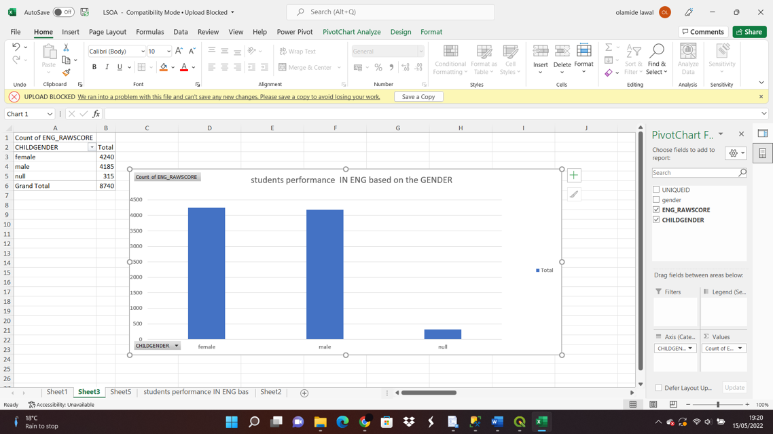

**REPORT 2**- The second report was to measure the inequality among the students on the number of times they eat and how it affects their academic performance , this report was chosen to measure the economic inequality among the pupils and how it affects their academic performance .From the result in this line chart , it can be seen that the ones that do not eat have the total score of 2152, the category of pupils that eat once have the total score of 985, the once that eat twice a day have the total score of 35458 , while the once that eat thrice a day have the total score of 145796. With this analysis it can be seen that the students that eat three times a day scored the highest and it shows that there is an economical inequality.It can be seen that their access to food has an effect on their performance , the ones that eat thrice a day perform better in school.

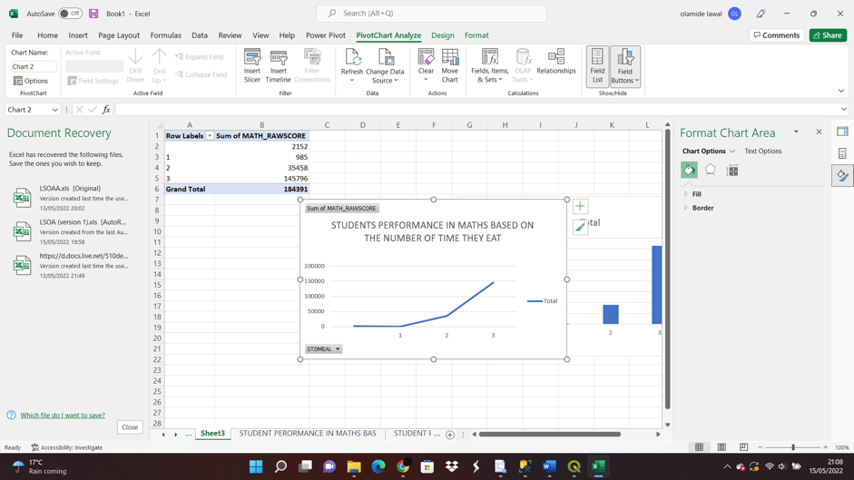

**REPORT 3** - The third report was to measure the inequality among the students on the locality they live and how it affects their academic performance , this report was also chosen to measure the economic inequality among the pupils based on their locality which was either rural or urban and how it affects their academic performance .From the result in this bar chart , it can be seen that the ones that live in rural areas have the total score of 4013, the category of pupils that live in urban areas have the total score of 4727. With this analysis it can be seen that the students that stay in urban areas scored the highest and it shows that there is an economical inequality because it shows that the ones that stay in the urban areas perform well in school and the environment is a big factor .

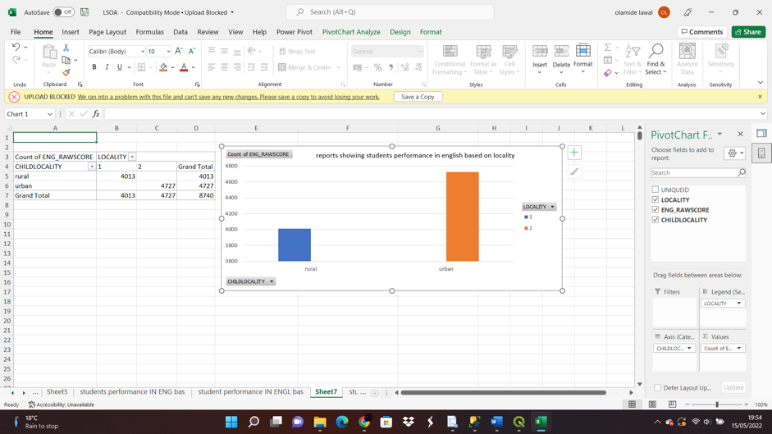

# Database Backup and Restore Strategy

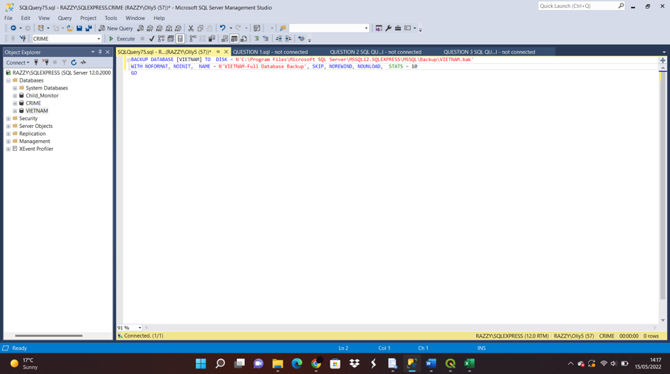

# Data Science /Business Intelligence –

Both business intelligence and data science are important in creating actionable insights in any organisation.The type of data they deal with to project deliverables and techniques, BI and data science differ in a number of ways.

# Data Privacy,Ethical and Legal Issues –

On the internet, unlawful data copying (data piracy), illegal access and interception, device misuse, computer-related forgeries, fraud and copyright and related rights infringements are all considered ethical issues.

# 

# Task 3

# Abstract

The aim of this project to build a report containing Lower Layer Super Output Areas (LSOAs) wise crime report with local population data in Greater Manchester between January 2017 and December 2018.At the initial stage of the project a database was created for this purpose , it was named ‘CRIME’. After which the Crimes data from the police data repository was imported were downloaded for each month and merged together using’UNION’ into a

table called ‘CRIME’. The Lower Layer Super Output Areas (LSOAs) datawas also imported into to SSMS for further analysis but only the Manchester population data that was needed was extracted into a new table called ‘Manchester’.

# Introduction

This project involves developing a reporting tool called Crime Profiler which is being created with the objective of the project is to develop a reporting tool called Crime Profiler to assist in the development of computational criminology as a part of the advancement of the theory and method in criminological research.In the process of this project the Crimes Data for Greater Manchester between Jan 2017 and Dec 2018 and Lower Layer Super Output Areas (LSOAs) . For better presentation of the reports the vehicle crime in Greater Manchester was visualized with QGIS using MSSQL Connector while making use of openstreetMap as OpenLayers plugin. While the Anti-social behaviours crimes in Salford was visualized with QGIS using MSSQL Connector making use of Google Satellite map as OpenLayers plugin.

# 3.Design Rationale

A design rationale explains the reasons why the design is the way its is , it involves a list of all decisions made during the design process and the reasons why those decisions were made. A design rationale explains the motives behind a particular design decision. The designs used for visualization were achieved with the use of QGIS for visualizing the vehicle crime in Greater Manchester use of openstreetMap as OpenLayers pluginwhile the Anti-social behaviours crimes in Salford was visualized with QGIS using Google Satellite map as OpenLayers plugin. is a virtual interface that allows users to explore and visualize spatial relationships within and among spatially explicit datasets,QGIS a geographical information system which is a virtual interface that permits the users to visualize and explore spatial relationships among spatially explicit datasets . This tool is valuable to this project because it deals with visualization of the results gotten from the results of analyzed data within a geographical environment .

# 4.Design Considerations

DATABASE NORMALISATION:

Database normalization is the process of arranging columns and tables of a database in a database to make sure that database integrity are effectively enforced.

CONSTRAINTS:

Constraints are implemented to limit the data type that are inserted in a table.Constraints are used to ensure the reliability of the type of data that go into a table.In the course of this project a good number of constraints were applied .some of the ones that were used in this project are as follows ;

* Not Null- it’s used to ensure that a column does not have a NULL value

DATAVALIDATION :

The data used in this task were validated in Microsoft excel before importing into ssms to ensure that the right data was correct and useful for analysis .

TRANSACTION AND CONCURRENCY:

This project had no reasons to use this controls because it’s not a transactional database The assignment did not use any of this controls because the database had no transactions , it was only used to analyse data .

SECURITY:

Database security can be seen as measures that are put in place to preserve the availability and confidentiality of a database . Database security protects the data , database management system , the virtual and physical server and the networking infrastructure used to access the database.

COMMENTS :

Comments were used to give better description to the statements or to stop the execution of sql statements.

TABLES :

In the process of analysing thevietnam school survey data , twelve tables were imported into sql_server management system (SSMS). These tables were created with columns in that have attibutes that contributes to the formation of each table . Twenty four tables representing the twenty four months between 2017 and 20018 were created by using the UNION statement to join the months

VIEWS

Views were created to store analysed data ,which were used to create reports/visualisation . The reports were done on different issues that are health related. The views created contributed in analysing the reports .the view were

# 5.T-SQL Statements

The screenshots below shows the statements used in creating tables and views in this project . The most vital statement is the SELECT statement because it was used in created the columns into the tables . twenty four tables representing the twenty four months between 2017 and 20018 were created after which the manchester population table was created , while four views were created to achieve reports on Vehicle crimes in Greater Manchester, Anti-social behaviours crimes in Salford , Number of crimes in 2017 and Number of crimes in 2018.

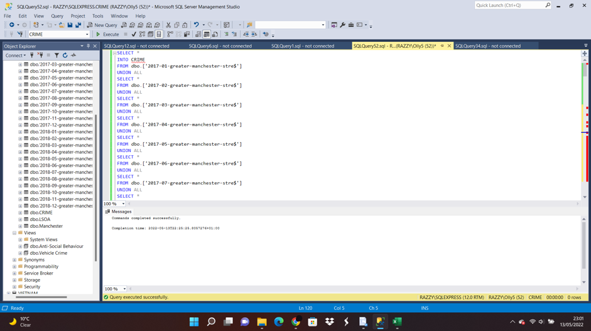

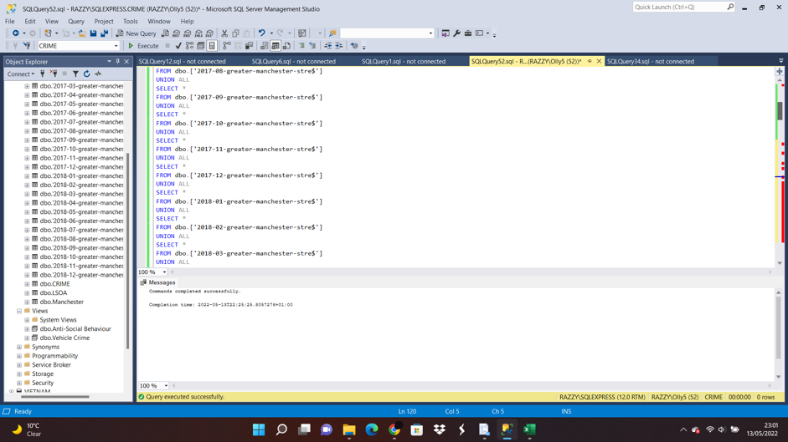

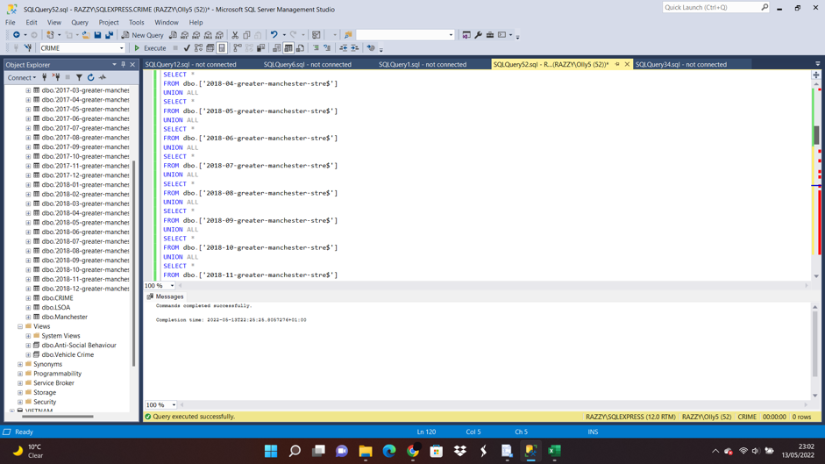

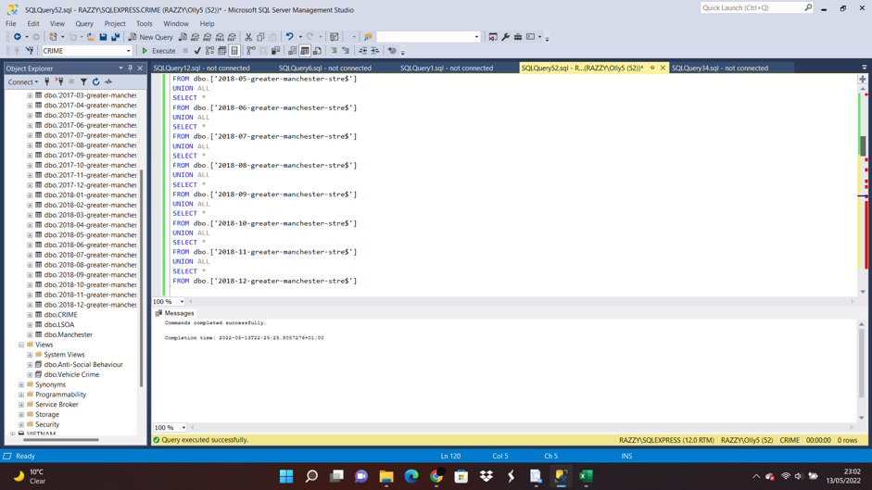

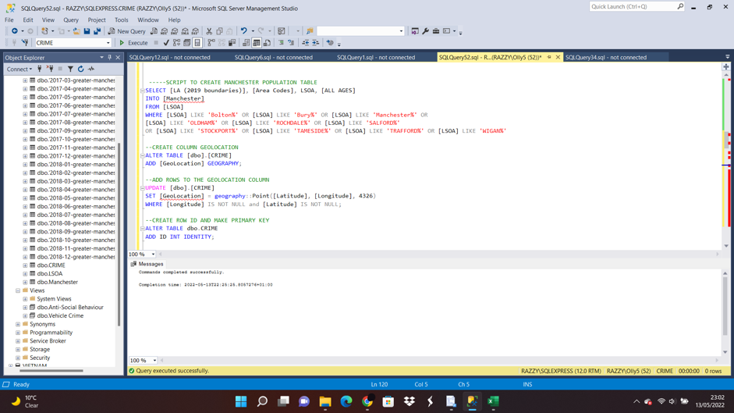

VIEWS

The following screenshots depicts the scripts on how the different views used in creating the reports were implemented .

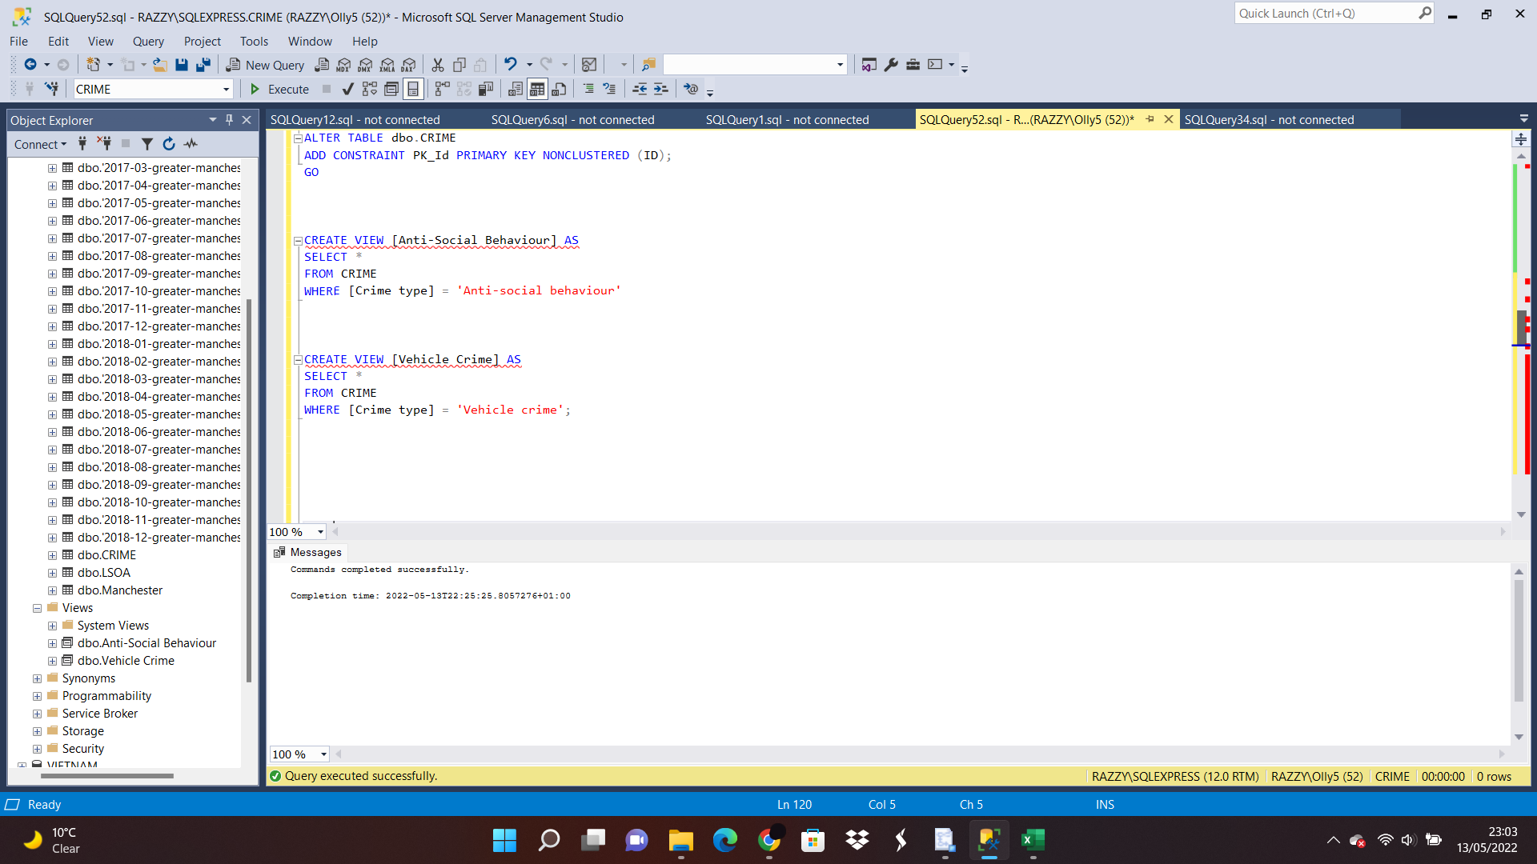

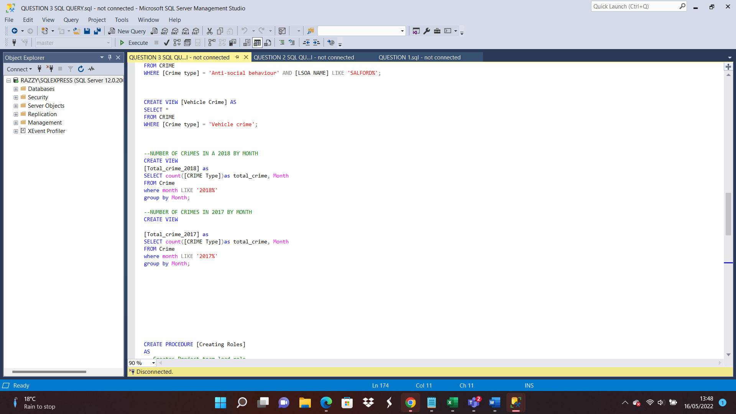

# 

# 5. Report Design

The reports to measure crime were visualized with Microsoft excel and QGIS, it consists of two charts that show the number of crime in 2017 and 2018 for each month and the reports on Vehicle crime in Greater Manchester on the Openstreet map and Antisocial behaviour on Google Satelite map.The two services assists in displaying the exact location were the crimes happened . To enable this visualization the geographic location was stored in a column named ‘Geolocation’.The longitude and latitude were also joined into the crime table .a primary key named – ID was also created .



(a) Vehicle crime in Greater Manchester

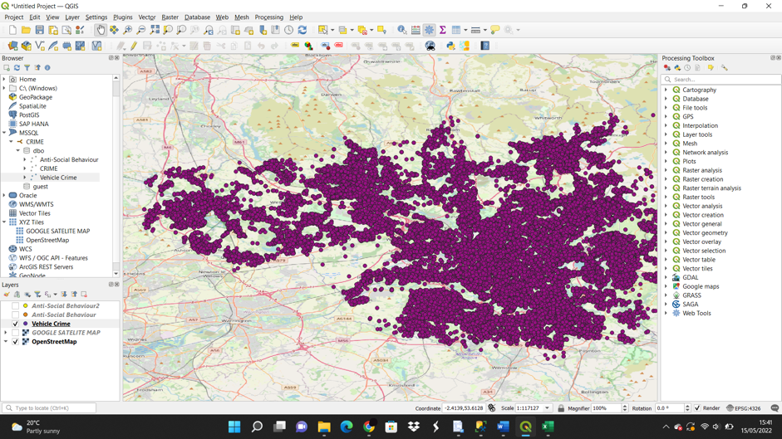

(b)Antisocial behaviour in Salford on Google Satelite map

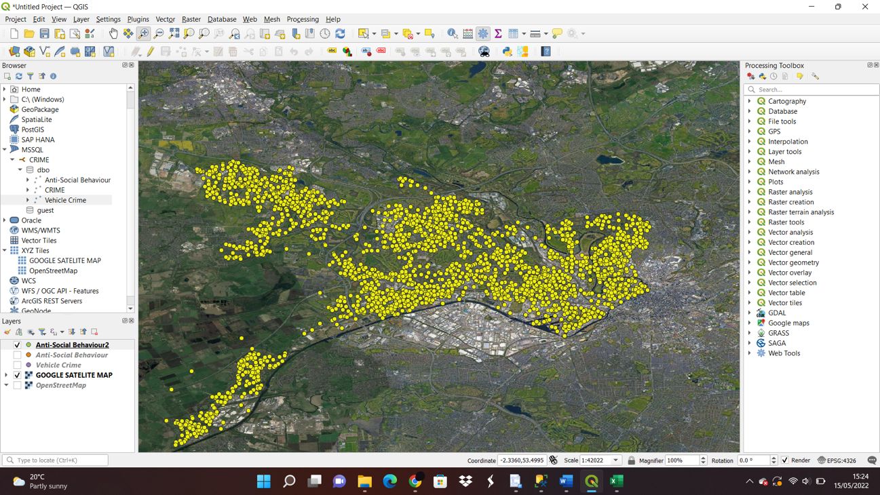

(c)Number of crimes in 2018

(d)Number of crimes in 2017

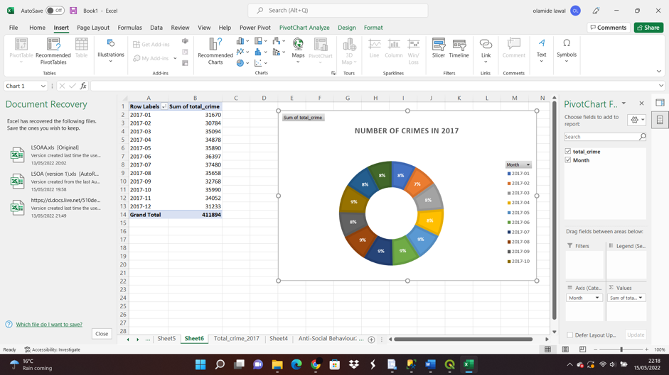

# 6.Database security

Database security refers to the measures that are put in place to preserve the confidentiality, integrity and availability of a database .

# 7.Database Backup and Restore Strategy

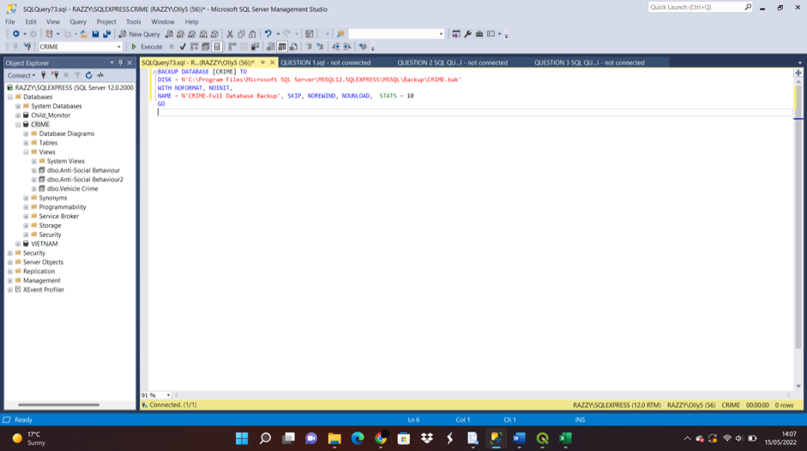

# 8.Data Science /Business Intelligence

Both business intelligence and data science are important in creating actionable insights in any organisation.The type of data they deal with to project deliverables and techniques, BI and data science differ in a number of ways.

# 9.Data Privacy,Ethical and Legal Issues

On the internet, unlawful data copying (data piracy), illegal access and interception, device misuse, computer-related forgeries, fraud and copyright and related rights infringements are all considered ethical issues.

# 10.Conclusion

The projects were successfully completed to provide a wide knowledge on “database systems” , three different databases were created in the process of completing this project .I had a better understanding on importing data from Microsoft excel into SSMS , creating three different databases and making use of this imported data to extract information by quering the data with Tsql statements after which visualisation was done with QGIS in task 3 and Microsoft excel in task 2 and 3 .

Reference Links

[1]https://www.younglives.org.uk/publications/young-lives-school-surveys-2016-17-vietnam-country-report

1.